Business Requirements Document (BRD)

**(Online Grocery App)**

**1. Introduction**

**1.1 Purpose**

The purpose of this document is to outline the business requirements for integrating a new shopping category, "Kitchen Appliances", into the existing online grocery app. This feature enhancement aims to expand the app's product offerings, increase customer satisfaction, and boost revenue.

**1.2 Scope**

The new category will include a variety of kitchen appliances such as blenders, microwaves, coffee makers, and more. It will integrate seamlessly with the existing app structure, providing users with a convenient shopping experience for both groceries and kitchen appliances.

**1.3 Definitions, Acronyms, and Abbreviations**

BRD: Business Requirement Document

UI: User Interface

UX: User Experience

API: Application Programming Interface

**2. Business Objectives**

**2.1 Primary Objectives**

- Enhance the app's competitive edge by offering a wider range of products.

- Increase average order value by encouraging cross-category purchases.

- Attract new customers interested in kitchen appliances while retaining existing grocery shoppers.

**2.2 Secondary Objectives**

- Improve customer retention through personalized recommendations and promotional offers.

- Streamline operations by integrating inventory and order management for the new category.

**3. Business Process**

**3.1 As is business process**

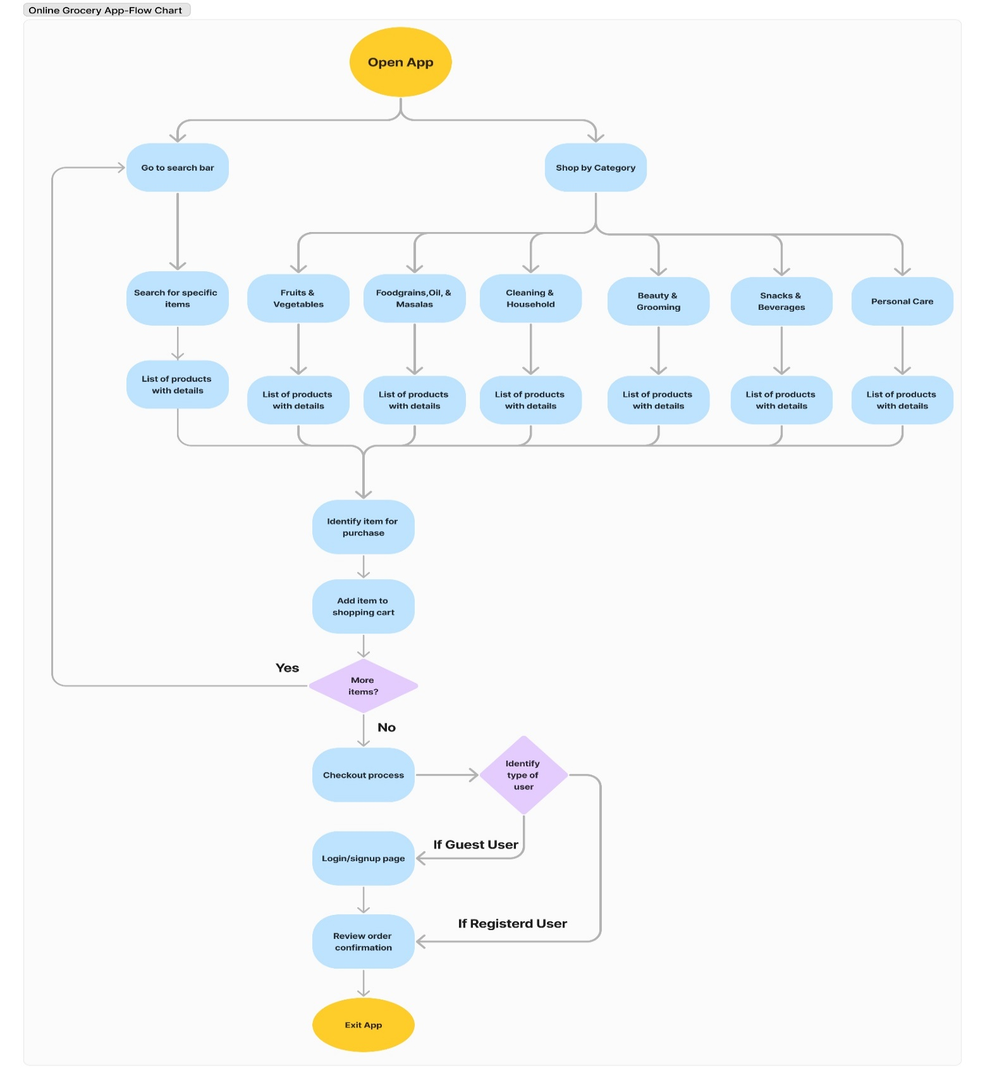

**3.2 To be business process**

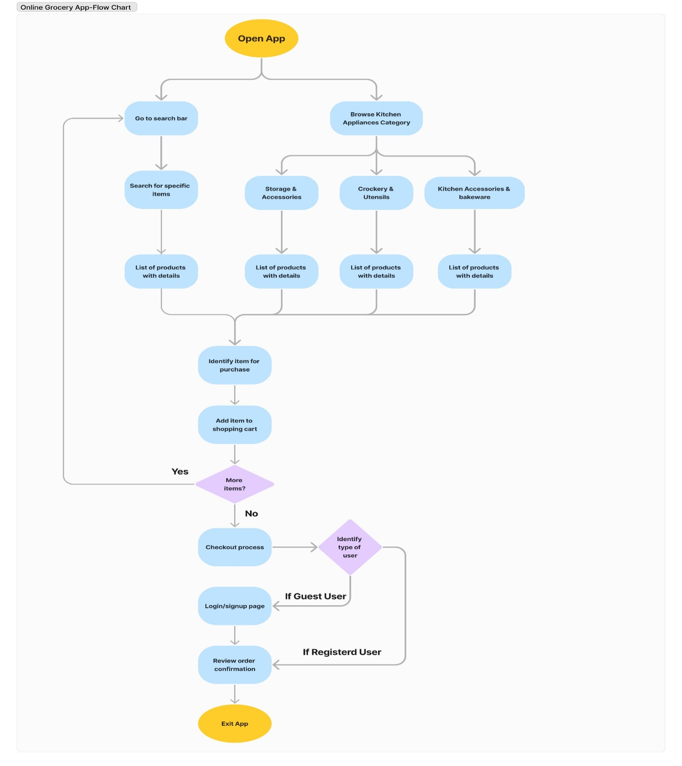

**4. Functional Requirements**

**4.1 User Module**

- **Browse and Search**:

- Users can browse ‘kitchen appliances’ category from ‘shop by category’ option.

- Search functionality specific to kitchen appliances (e.g., by brand, type).

- **Product Details**:

- Display detailed descriptions, images, specifications, and customer reviews for each appliance.

- **Add to Cart and Checkout**:

- Users can add appliances to the cart and proceed with checkout.

- Integration with existing payment gateways for secure transactions.

- **Order Tracking**:

- Track delivery status of appliances similar to groceries.

- **Customer Account**:

- Manage orders, track order history, and view personalized recommendations across categories.

**4.2 Admin Module**

- **Dashboard**:

- Overview of sales analytics, inventory levels, and customer feedback for kitchen appliances.

- **Product Management**:

- Add, edit, delete kitchen appliances with attributes (e.g., price, stock availability, specifications).

- **Order Management**:

- View, update, and fulfill orders for kitchen appliances.

- **Inventory Management**:

- Sync inventory levels with suppliers and manage stock for appliances.

**4.3 Integration Requirements**

- **Database Integration**:

- Integrate new kitchen appliances category into existing product database.

- **Payment Gateway Integration**:

- Extend payment gateway options to include appliances.

- **Shipping Integration**:

- Integrate with shipping carriers for appliance deliveries.

**5. Non-Functional Requirements**

**5.1 Performance**

- Ensure app performance remains optimal during peak traffic times.

- Response times for browsing, searching, and adding products should meet industry standards.

**5.2 Security**

- Implement robust security measures for handling payment information and user data.

- Compliance with GDPR (General data protection regulation) and other data protection regulations.

**5.3 Usability**

- Maintain consistent UI/UX design across groceries and appliances categories.

- Seamless integration with existing categories.

**6. Constraints**

- **Budget**: Development and integration costs should not exceed X INR.

- **Timeline**: Feature rollout targeted within X weeks to align with marketing campaigns and seasonal promotions.

- **Technological Compatibility**: Ensure compatibility with existing app infrastructure and third-party systems.

**7. Assumptions and Dependencies**

- **Assumptions**: Users have internet access and compatible devices to access the app.

- **Dependencies**: Integration with third-party APIs for payment processing and shipping logistics.

**8. Risks and Mitigation Strategies**

- **Risk**: Potential delays in product integration or technical issues during rollout.

- **Mitigation**: Conduct thorough testing and implement a phased rollout strategy.

**9. Sign-off**

This Business Requirement Document (BRD) is approved by

|  |  |  |  |  |
| --- | --- | --- | --- | --- |
| **Role** | **Name** | **Title** | **Signature** | **Date** |
| Project Sponsor |  |  |  |  |
| Business Owner |  |  |  |  |
| Product Owner |  |  |  |  |
| System Architect |  |  |  |  |
| Development Lead |  |  |  |  |